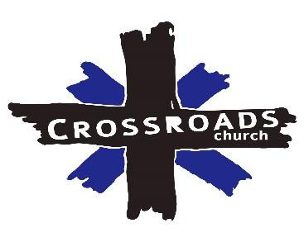
Recurring ACH Payment Authorization

I (Full Name) __________________________________ authorize Crossroads Church to charge my bank account for $____________________ on the (circle one) 1st or the 15th of each month, as a donation.

Personal Info:
Phone:______________________________________________
Email:_______________________________________________

Bank Info:
Withdrawal comes from (Circle One): checking or Savings
Bank Name:__________________________________________
Account Number:_____________________________________
Routing Number:______________________________________
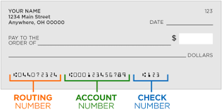

I understand this authorization will remain in effect until otherwise notified.
Signature: ___________________________ Date:_____________

